Supplementary Material

Design of Polymeric Nanoantibiotics: N-acetylcysteine-Functionalized PLA-PEG Nanoparticles for Linezolid and Pentamidine Delivery

Antonia Nostro,¹ Giovanna Ginestra, ¹ Federica Grasso,¹ Massimiliano Cordaro, ¹ Anna Piperno, ¹ Angelo Nicosia,² and Angela Scala^{1,}*

¹ Department of Chemical, Biological, Pharmaceutical and Environmental Sciences, University of Messina, V.le F. Stagno d’Alcontres 31, 98166 Messina, Italy
² Department of Chemical Sciences, University of Catania, V.le A. Doria, 95125 Catania, Italy

Table of content:
Figure S1. ¹H NMR spectra of NAC (1), 11-azido-3,6,9-trioxaundecan-1-amine (2), and NAC-azide (3).
Figure S2. ¹³C NMR spectrum of NAC-azide (3)
Figure S3. gHSQCAD of NAC-azide (3)
Figure S4. gCOSY of NAC-azide (3)
Figure S5. ESI-MS spectrum of NAC-azide (3)
Figure S6. ¹H NMR spectrum of PEG-monoAlkyne (6)
Figure S7. FT-IR spectra of NAC-azide (3), PLA-PEG-NAC (9), PLA-PEG-alkyne (8) and native PLA (7).
Figure S8. ¹H NMR spectrum of crotonyl-amide-BODIPY (12)
Figure S9. ESI-MS spectrum of crotonyl-amide-BODIPY (12)
Table S1. Parameters from the first order-fitting of cumulative release curves
Figure S10. Fluorescence images of S. aureus (MRSA) biofilm formation in the presence of PLA-PEG-NAC@LNZ NPs and free LNZ

Figure S1. ¹H NMR spectra of NAC (1, red trace), 11-azido-3,6,9-trioxaundecan-1-amine (2, green trace), NAC-azide (3, black trace). All the NMR spectra were recorded in CD₃OD at r.t.

Figure S2. ¹³C NMR spectrum of NAC-azide (3) (500 MHz, CD₃OD)

Figure S3. gHSQCAD of NAC-azide (3) (500 MHz, CD₃OD)

Figure S4. gCOSY of NAC-azide (3) (500 MHz, CD₃OD)

Figure S5. ESI-MS spectrum of NAC-azide (3)

Figure S6. ¹H NMR spectrum of PEG-monoAlkyne (6) (500 MHz, CDCl₃)

Figure S7. FT-IR spectra of NAC-azide (3), PLA-PEG-NAC (9), PLA-PEG-alkyne (8) and native PLA (7). In the inset, magnification of the 2050-2150 cm⁻¹ region to visualize the weak band for the triple bond (–C≡C–) of PLA-PEG-alkyne.

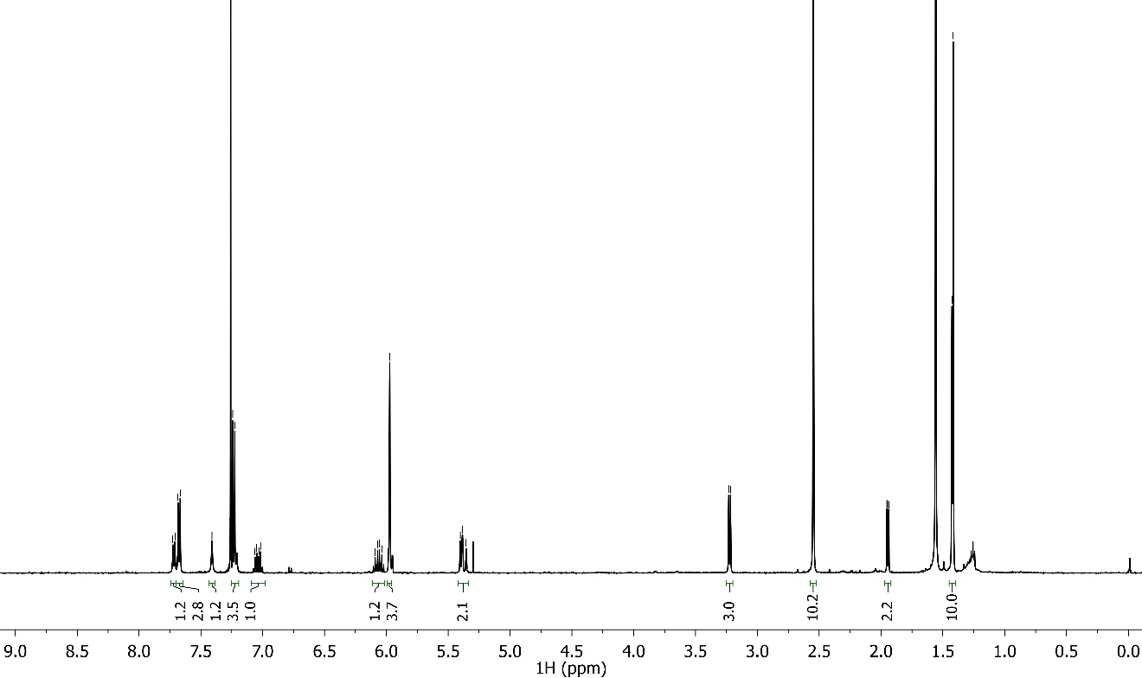
Figure S8. ¹H NMR spectrum of crotonyl-amide-BODIPY (12) (500 MHz, CDCl₃)

Figure S9. ESI-MS spectrum of crotonyl-amide-BODIPY (12)

Table S1. Parameters from the first order-fitting of cumulative release curves for free drugs (LNZ and Pent) and drug-loaded NPs (PLA-PEG-NAC@LNZ NPs and PLA-PEG-NAC@Pent NPs).

Sample | First-order
Sample | $$Mt=M_{0}+Ae^{-Kt}$$
Sample | K | R²
Free LNZ | -0.21571 | 0.99568
Free Pent | -0.16328 | 0.9977
PLA-PEG-NAC@LNZ NPs | -0.07249 | 0.99417
PLA-PEG-NAC@Pent NPs | -0.02781 | 0.99702

Figure S10. Representative fluorescence images of S. aureus (MRSA) biofilm formation in the presence of PLA-PEG-NAC@LNZ NPs and free LNZ observed in green channel (SYTO 9), red channel (propidium iodide, PI) and as merged images (overlay of SYTO 9 and PI). Images observed with inverted microscope Axio Observer.Z1 equipped with an Apotome 3 and acquired with ZEN 3.12 software. Magnification 100X.

