Supporting Information
Protoporphyrin-grafted halloysite nanotubes for boosted photodynamic activity in chitosan nanocomposite films

Marina Massaro,ª Federica Leone,ª Angelo Nicosia,^{b} Giuseppe Lazzara,^{c} Giuseppe Cavallaro,^{c} Grazia M. L. Messina,^{b} Cèsar Viseras,^{d,e} Rita Sanchez-Espejo,^{d} Monica Notarbartolo,ª Roberta Puglisi,^{b} Placido G. Mineo,^{b} Raquel de Melo Barbosa,^{f} Serena Riela ^{b*}

ªDipartimento di Scienze e Tecnologie Biologiche, Chimiche e Farmaceutiche (STEBICEF), Università di Palermo, Viale delle Scienze, Parco d’Orleans II, Ed. 16-17, 90128 Palermo, Italy.
^{b}Dipartimento di Scienze Chimiche (DSC), Università di Catania, Viale Andrea Doria 6, 95125 Catania, Italy
^{c}Dipartimento di Fisica e Chimica E. Segrè (DiFC), Università di Palermo, Viale delle Scienze, Parco d'Orleans II, Ed. 17, 90128 Palermo, Italy
^{d}Department of Pharmacy and Pharmaceutical Technology, Faculty of Pharmacy, University of Granada, Campus Universitario de Cartuja, 18071 Granada, Spain
^{e}Andalusian Institute of Earth Sciences, CSIC-UGR, 18100 Armilla, Granada, Spain
^{f}Department of Pharmacy and Pharmaceutical Technology, School of Pharmacy, University of Seville, C/Professor García González 2, 41012 Sevilla, Spain

Total number of pages: 7
Total number of tables: 1
Total number of Figures: 4

Table of Content
1. FTIR spectra of Hal-PPIX obtained via UV irradiation….…………...……S3
2. Absorption and emission spectra of Hal-PPIX obtained via UV irradiation………………………………………………………………………S4
3. XPS analysis of Hal-PPIX obtained via UV irradiation …………………...S5
4. Table of percentage of C, N and O atoms, as determined by XPS measurements for Hal-PPIX nanomaterials …………………………………………………..S6
5. UV-vis and fluorescence spectra of PPIX, PPIX@Zn and Hal based nanomaterials…………………………………………………………………..S7
6. Plot of the change in absorbance of DPBF in the presence of nanomaterials…S8
7. Height atomic force microscopy image of films……………………………..S9

Figure S1. FT-IR spectra of PPIX, HNTs and HNTs-PPIX nanomaterial obtained via UV irradiation.

Figure S2. Absorption (black line) and emission (blue line) spectra of HNTs-PPIX nanomaterial obtained via UV irradiation (0.5 mg mL⁻¹, methanol, r.t.).

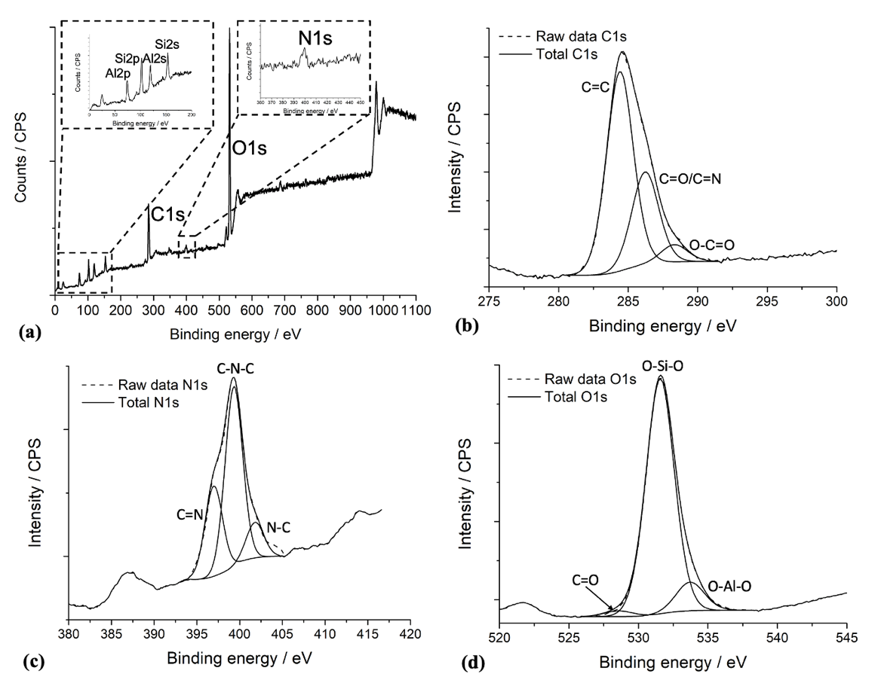
Figure S3. (a) XPS survey of HNTs-PPIX nanomaterial obtained via UV irradiation, (b) deconvoluted C 1s spectrum; (c) deconvoluted N 1s spectrum, (d) deconvoluted O 1s spectrum.

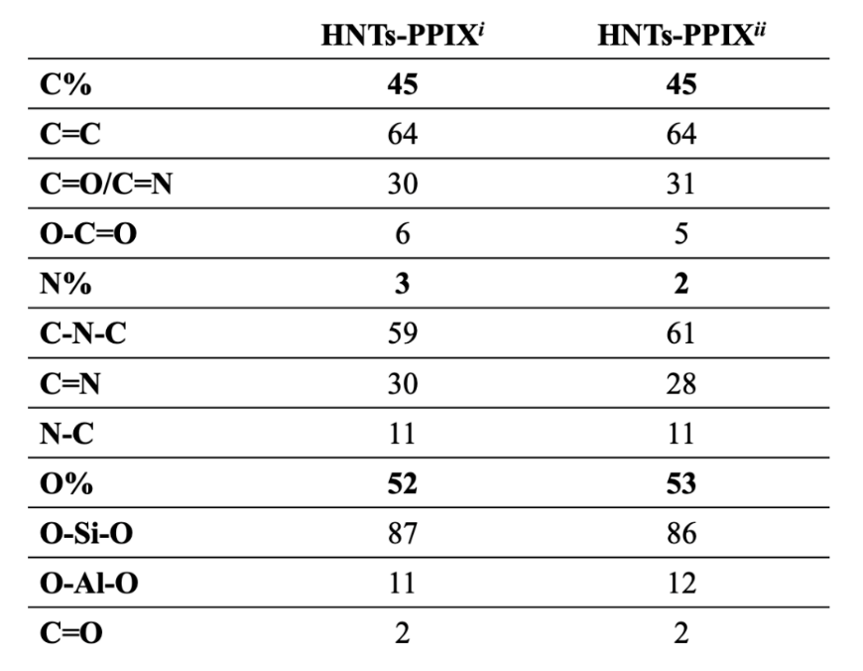
Table S1. Percentage of C, N and O atoms, as determined by XPS measurements for HNTs-PPIX nanomaterials obtained with the two different pathways.

Figure S4. UV-vis spectra of PPIX, PPIX@Zn and their Hal based nanomaterials.

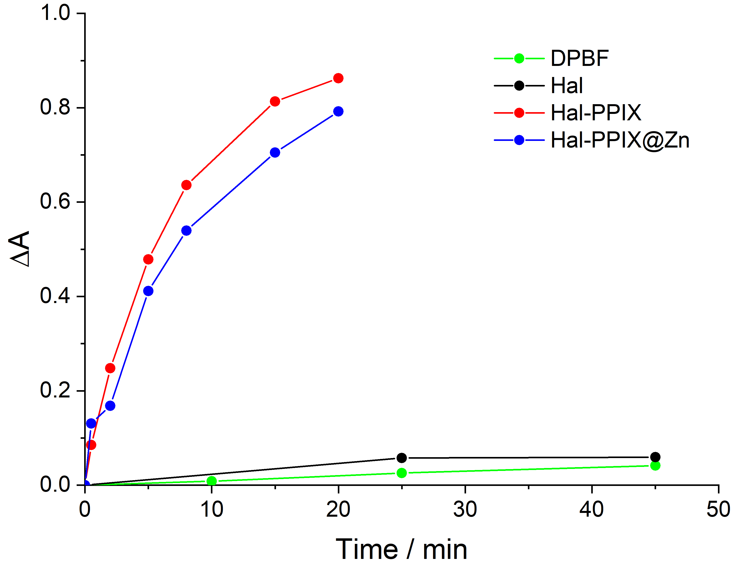

Figure S5. Plot of the change in absorbance of DPBF as function of irradiation time in the presence of synthetized nanomaterials.

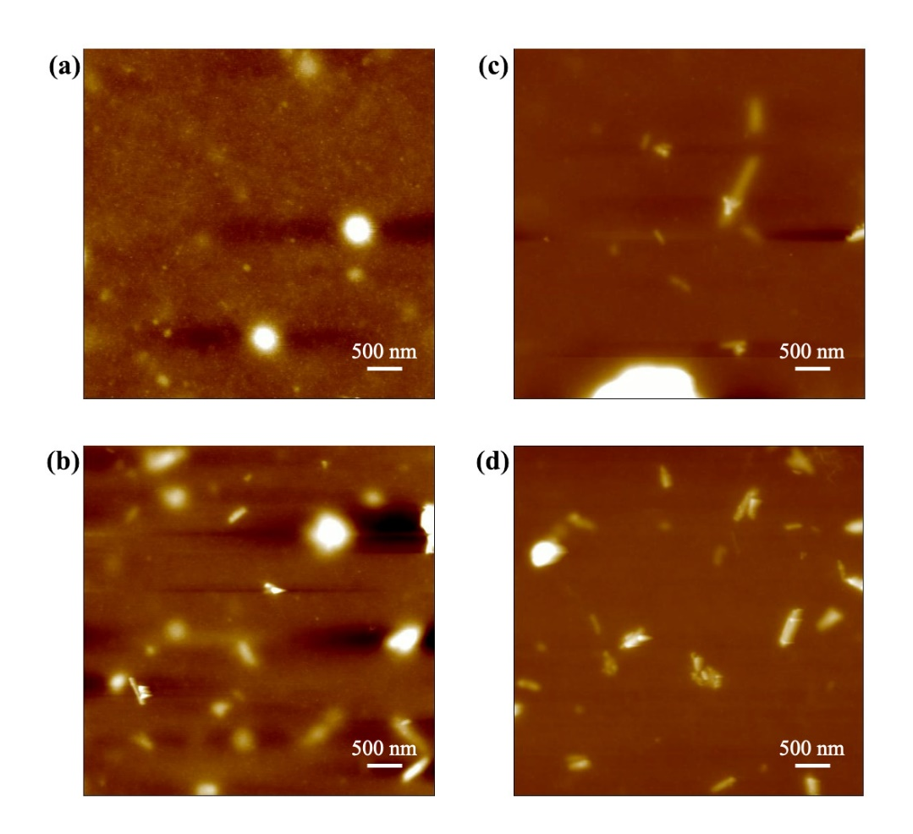
Figure S6. Height atomic force microscopy image of (a) Chitosan, (b) Chitosan/Hal, (c) Chitosan/Hal-PPIX, (d) Chitosan/Hal-PPIX@Zn films.

