Supplementary Material
Figure S1. Contact angle measurements for rGO surfaces produced in solvents containing -OH groups
Figure S2. Contact angle measurements for rGO surfaces produced in linear aliphatic hydrocarbons

Table S1: Solvent parameters used
Solvent | Boiling point (°C) | Dipole moment (D) | Hildebrand parameter (Mpa^{1/2}) | Surface tension (mN/m) | Thermal conductivity (mW/m*K)
NMP | 202 | 4.09 | 18 | 40.1 | 0.18
Methanol | 64.7 | 2.87 | 29.7 | 22.5 | 0.2
DMF | 153 | 3.86 | 24.7 | 37.1 | 0.184
Ethanol | 78.4 | 1.66 | 26.2 | 22.3 | 0.169
IPA | 82.5 | 1.66 | 23.8 | 23 | 0.154
Toluene | 110.6 | 0.31 | 18.3 | 28.4 | 0.141
Buthanol | 117.7 | 1.75 | 28.7 | 24.6 | 0.154
EthylAcetate | 77.1 | 1.88 | 18.2 | 23.7 | 0.144
Acetone | 56 | 2.69 | 19.7 | 25.2 | 0.16
EthylEther | 34.6 | 1.15 | 15.4 | 17.1 | 0.13
Hexane | 68.7 | 0.08 | 14.9 | 18.4 | 0.117
Cyclohexsane | 80.75 | 0 | 16.8 | 24.9 | 0.11
Pentane | 36.1 | 0 | 14.4 | 15.5 | 0.113

Figure S3. Correlation of contact angle measurements with the boiling point of the corresponding solvents

Figure S4. Correlation of contact angle measurements with the dipole moment of the corresponding solvents
Figure S5. Correlation of contact angle measurements with the surface tension of the corresponding solvents
Figure S6. Correlation of contact angle measurements with the Hildebrand parameter of the corresponding solvents

Figure S7. Summary of statistical analysis performed by JMP software
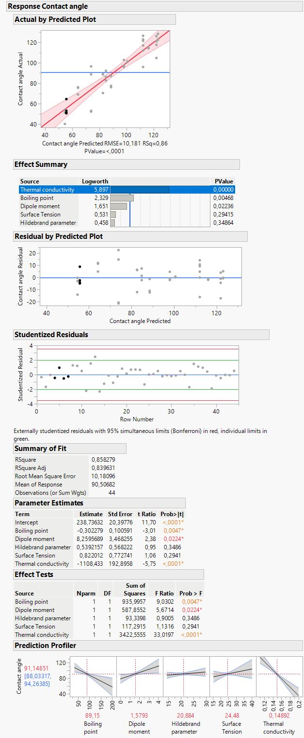
Figure S8. Contact angle measurements at different scan rates for (a) hexane and (b) cyclohexane

Figure S9. (a) Extended XPS spectra from representative samples. (b) N1s and (c) high-resolution XPS spectra from a sample obtained in NMP.

Figure S10. Representative Raman spectra from samples obtained in different solvents

Figure S11. SEM images taken at 1K magnification from samples obtained in different solvents
