CO₂ conversion by solar photothermo co-catalysis on Montmorillonite-based catalysts
Giusy Dativo¹, Marcello Condorelli¹, Giuseppe Compagnini¹, Giuliana Impellizzeri², Salvatore Scirè¹ and Roberto Fiorenza^{1,2*}
¹Department of Chemical Sciences, University of Catania,V.le A. Doria 6, Catania 95125, Italy
²Institute for Microelectronics and Microsystems (IMM), National Research Council (CNR), Via S. Sofia 64, Catania 95123, Italy
*corresponding author: rfiorenza@unict.it

Supporting information

- UV-DRS measurements

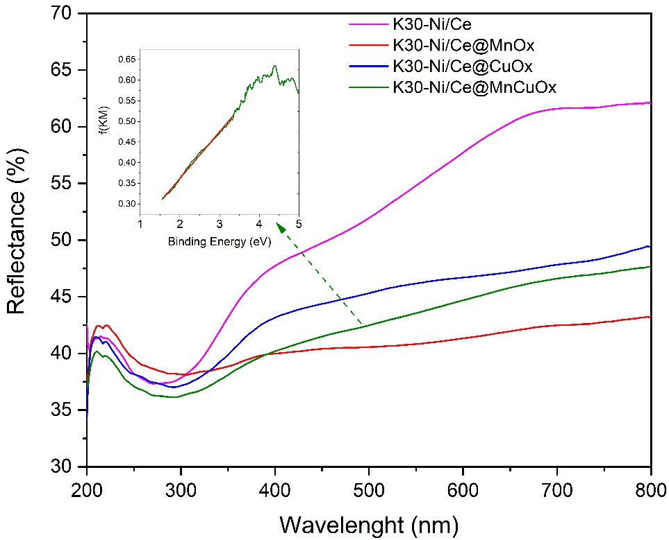
Figure S1 UV-DRS spectra of the examined samples. In the inset the plot of modified Kubelka function evaluated for the estimation of the optical band gap (K30-Ni/Ce@MnCuO_{x} chosen as representative sample).

- SEM, EDX spectrum and Raman intensity map (peak at 490 cm⁻¹) of K30-Ni/Ce@MnCuO_{x}
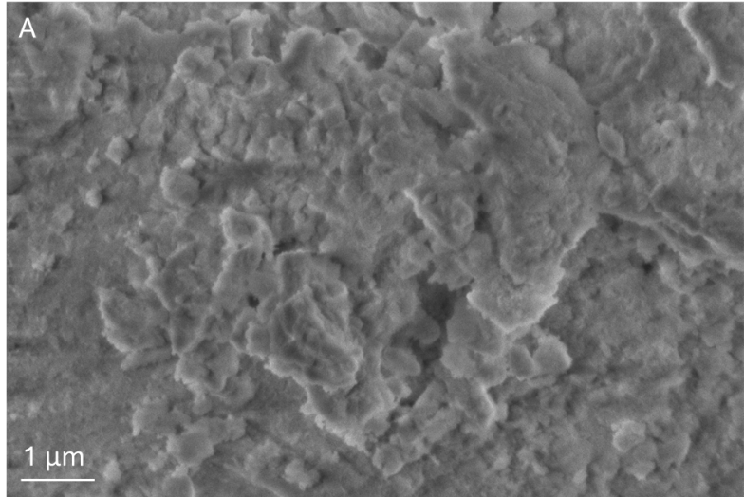
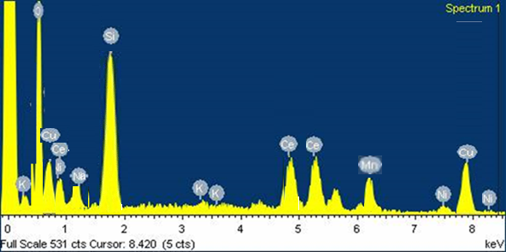
B

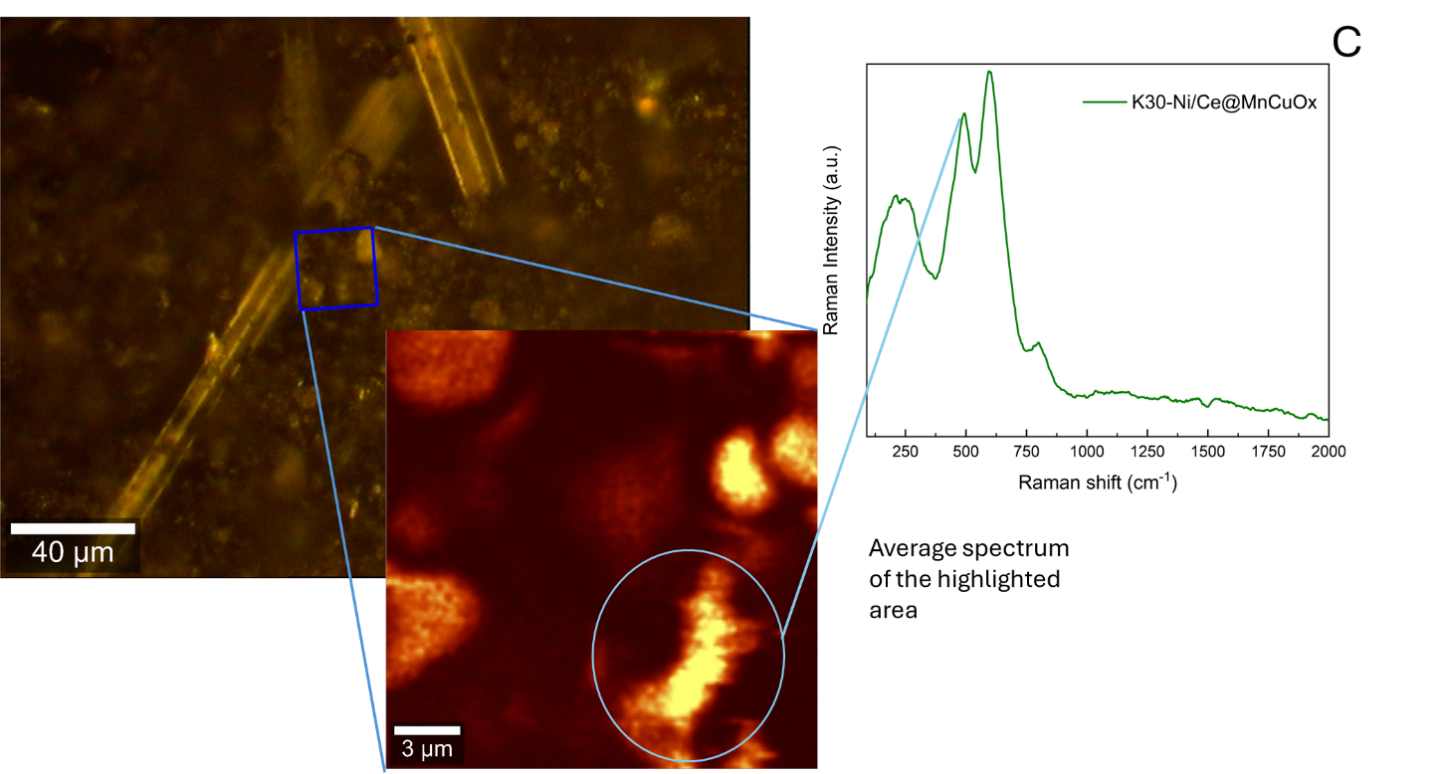

Figure S2 (A) SEM image of the K30-Ni/Ce@MnCuO_{x} catalyst as representative sample. The other K30-based composites showed a similar morphology; (B) EDX spectrum; (C) Raman Intensity map.

Table S1 Elements detected by EDX for the K30-Ni/Ce@MnCuO_{x} catalyst.
Element | Weight%
O | 44.2
Si | 20.3
K | 0.7
Ni | 7.4
Ce | 7.1
Mn | 4.6
Cu | 5.1
Al | 7.1
Na | 2.3
Mg | 1.2

- EDX analysis of K30-Ni/Ce, K30-Ni/Ce@MnO_{x} and K30-Ni/Ce@CuO_{x}
Table S2 Elements detected by EDX for the K30-Ni/Ce@MnO_{x} catalyst.
Element | Weight%
O | 42.5
Si | 22.6
K | 0.4
Ni | 7.3
Ce | 7.4
Mn | 9.4
Al | 7.0
Na | 2.1
Mg | 1.3

Table S3 Elements detected by EDX for the K30-Ni/Ce@CuO_{x} catalyst.
Element | Weight%
O | 41.5
Si | 22.7
K | 0.4
Ni | 7.1
Ce | 7.0
Cu | 10.6
Al | 6.8
Na | 2.2
Mg | 1.7

Table S4 Elements detected by EDX for the K30-Ni/Ce catalyst.
Element | Weight%
O | 45.4
Si | 28.7
K | 0.4
Ni | 7.6
Ce | 7.4
Al | 6.5
Na | 2.5
Mg | 1.5

- XPS spectra in the Cu 2p region of K30-Ni/Ce@CuO_{x} and K30-Ni/Ce@MnCuO_{x} samples

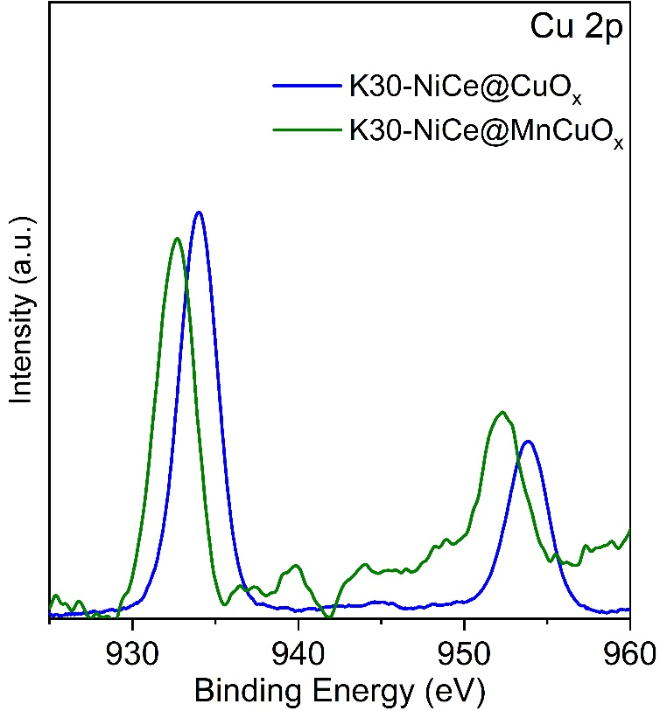

Figure S3 XPS spectra of the examined samples measured in the Cu 2p binding energy region.

- Photothermo-catalytic activity of Bentonite-Ni/Ce@MnCuO_{x} and K30-Ni/Ce@MnCuO_{x}

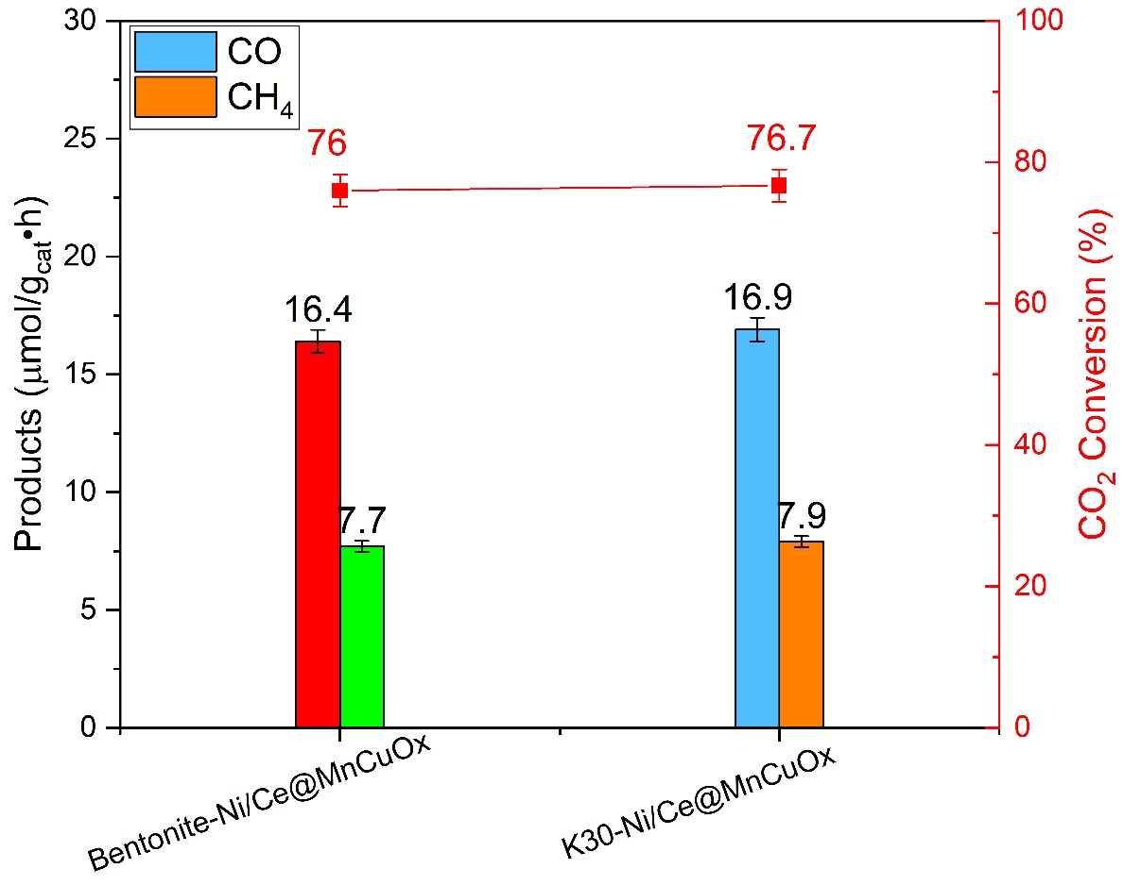
Figure S4. Photothermo-catalytic CO₂ conversion at T = 120 °C after 5 h of simulated solar irradiation on the investigated samples.

