H₂ Production by solar photoreforming of plastic materials using SiC-g-C₃N₄ composites
Maria Teresa Armeli Iapichino¹, Roberto Fiorenza^{1*}, Vincenzo Patamia², Giuseppe Floresta², Antonino Gulino^{1,3}, Marcello Condorelli¹, Giuliana Impellizzeri⁴, Giuseppe Compagnini¹ and Salvatore Sciré¹
¹ Department of Chemical Sciences, University of Catania, V.le A. Doria 6, 95125 Catania, Italy;
² Department of Drug and Health Sciences, University of Catania, V.le A. Doria 6, 95125, Catania, Italy
³ INSTM UdR of Catania, V.le A. Doria 6, 95125 Catania, Italy
⁴ CNR-IMM, Via S. Sofia 64, 95123, Catania, Italy

*Corresponding author: rfiorenza@unict.it

Supporting information
- ¹H-NMR Spectra

Before
After
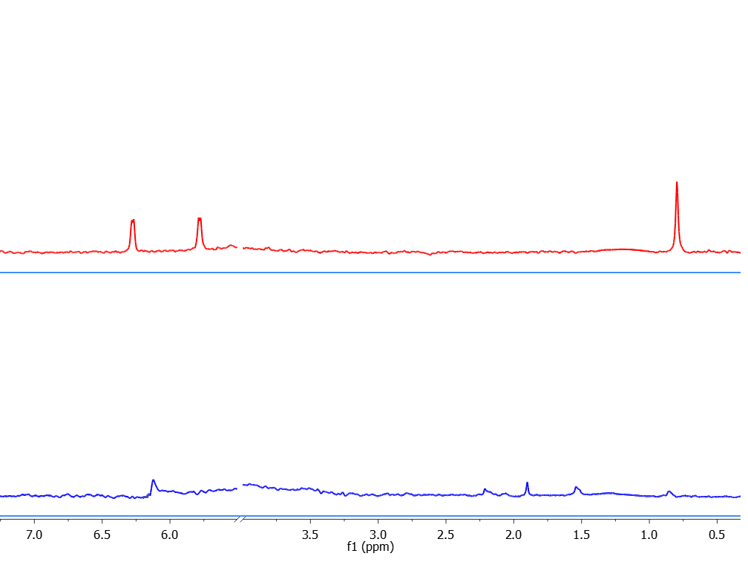

Figure S1 ¹H NMR spectra carried out before and after the BPA photoreforming using the SiC-0.5%g-C₃N₄ composite
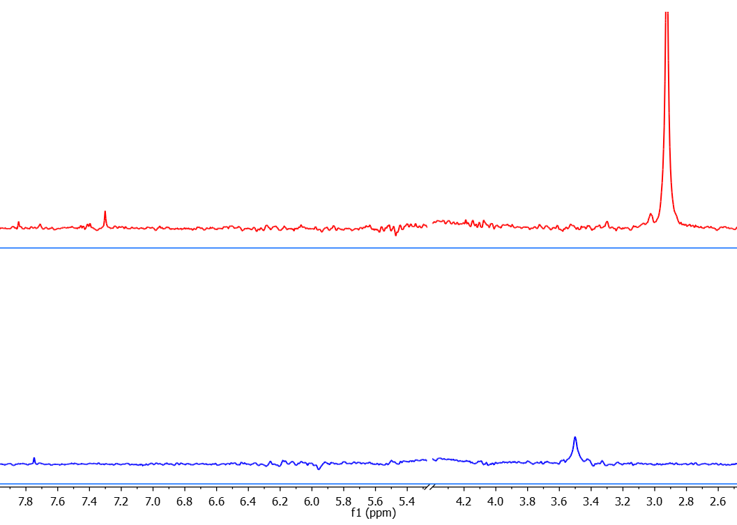
Before
After

- UV-DRS Spectra

Figure S2 ¹H NMR spectra carried out before and after the PET photoreforming using the SiC-1%g-C₃N₄ composite

- UV-DRS Spectra

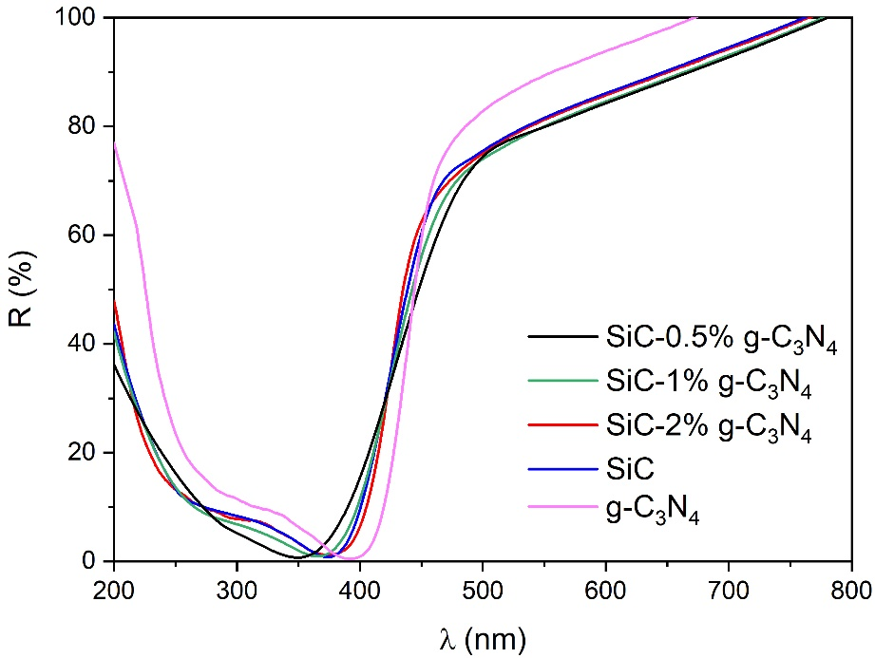
Figure S3 UV-DRS spectra of the SiC-g-C₃N₄-based samples

- TEM images of the bare SiC and of the SiC-1%g-C₃N₄ samples
A
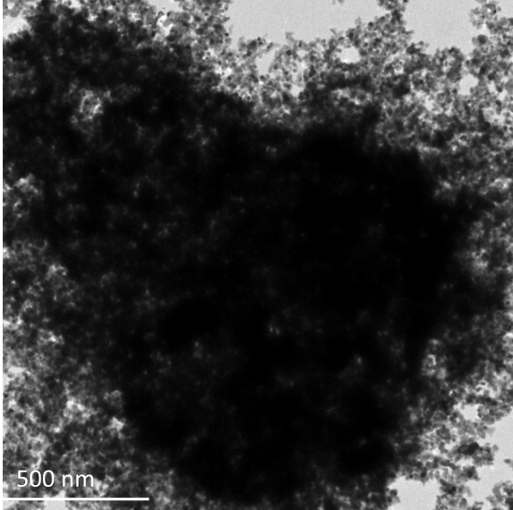

B
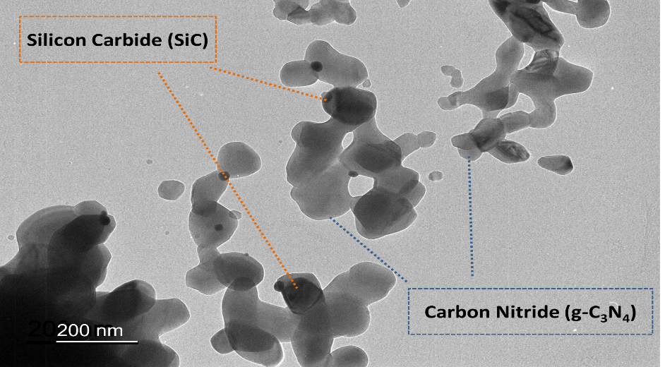

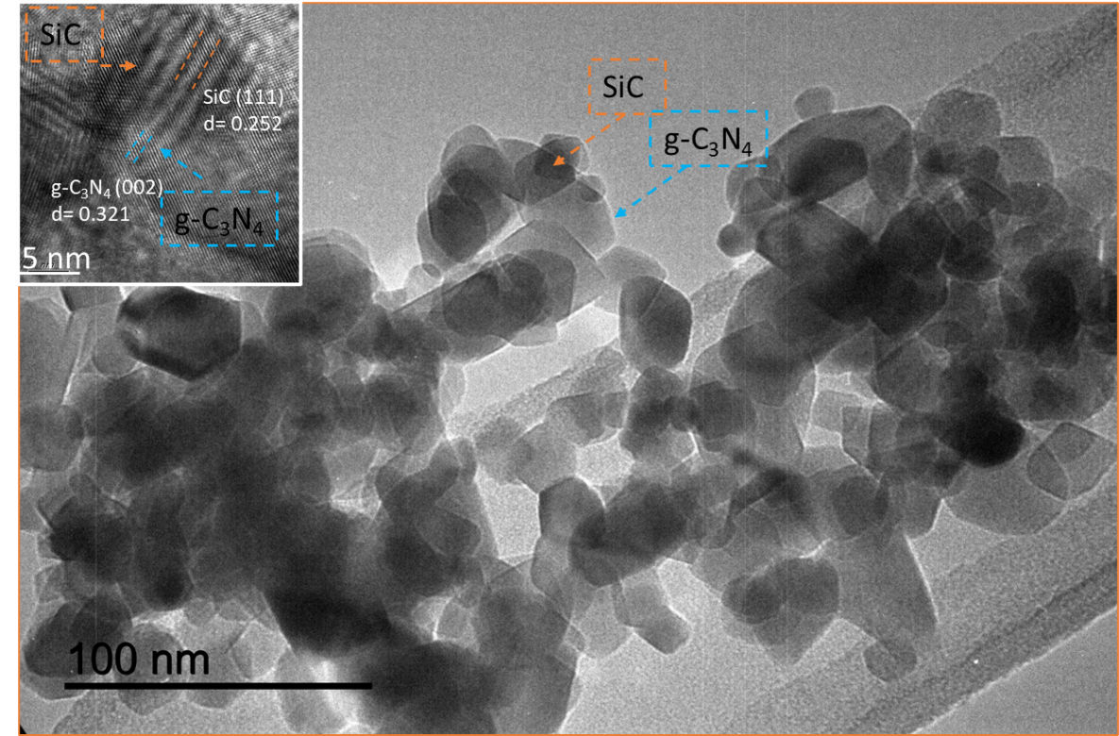
C

Figure S4 TEM images of the bare SiC (A) and of SiC 1% g-C₃N₄ (B) samples. In the figure S4A it is possible to note the agglomerated SiC particles (dark part) formed due to the employed thermal treatment (calcination at 450°C for 5 h). In the figure S4B the darker parts (indicated with the orange arrows) show the SiC particles, whereas the g-C₃N₄ sheets where indicate by the blue arrows (the clearest parts) in accordance with the literature data [1,2]. In the figure S4C it is illustrated the HR-TEM of the same SiC 1% g-C₃N₄ composite at two different magnifications (see inset). It is confirmed the interaction between the agglomerated SiC particles and the g-C₃N₄ sheets, as reported for similar composites [3-6]. The measured interplanar crystal spacing distances are close to the (002) and (111) lattice planes of g-C₃N₄ and SiC respectively, in accordance with the main crystal plans of the two materials detected by XRD.

- XPS spectra of the bare SiC

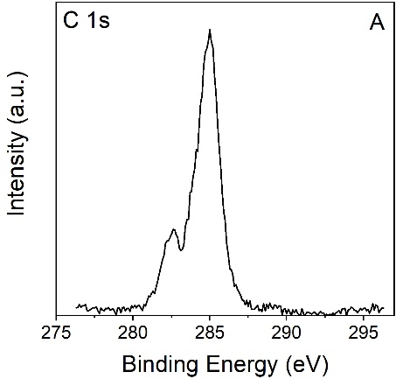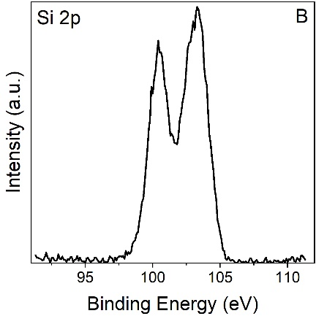

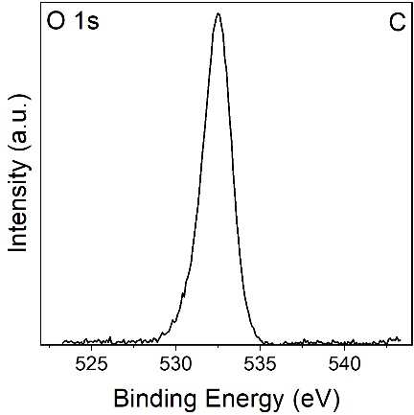

Figure S5 Al Kα excited XPS of the bare SiC sample in the (A) C 1s (B) Si 2p, and (C) O 1s binding energy regions.

- XPS spectra of the g-C₃N₄

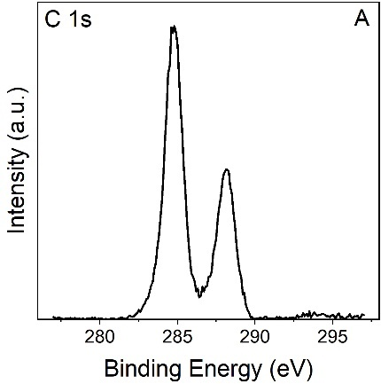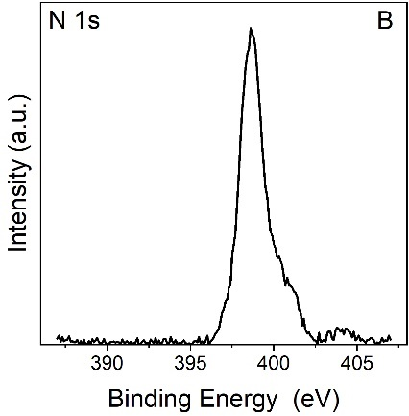

Figure S6 Al Kα excited XPS of g-C₃N₄ sample in the (A) C 1s and (B) N 1s binding energy regions.

References
[1] Z. Du, P. Sun, K. Wu, X. Zheng, X. Zhang, J. Huang, D. Sun, Y. Zheng, Q. Li, g-C3N4-SiC-Pt for Enhanced Photocatalytic H2 Production from Water under Visible Light Irradiation, Energy Technol. 7 (2019) 1–10. https://doi.org/10.1002/ente.201900017.
[2] B. Wang, J. Zhang, F. Huang, Enhanced visible light photocatalytic H 2 evolution of metal-free g-C 3 N 4 /SiC heterostructured photocatalysts, Appl. Surf. Sci. 391 (2017) 449–456. https://doi.org/10.1016/j.apsusc.2016.07.056.
[3] N. Zhang, S. Qiao, H. Wu, A. Fakhri, V.K. Gupta, Sustainable nano-composites polyglutamic acid functionalized Ag/g-C3N4/SiC for the ultrasensitive colorimetric assay, visible light irradiated photocatalysis and antibacterial efficiency, Opt. Mater. (Amst). 120 (2021) 111452. https://doi.org/10.1016/j.optmat.2021.111452.
[4] U. Baig, M.A. Gondal, M.A. Ansari, M.A. Dastageer, M. Sajid, W.S. Falath, Rapid synthesis and characterization of advanced ceramic-polymeric nanocomposites for efficient photocatalytic decontamination of hazardous organic pollutant under visible light and inhibition of microbial biofilm, Ceram. Int. 47 (2021) 4737–4748. https://doi.org/10.1016/j.ceramint.2020.10.043.
[5] Z. Wu, Y. Li, X. Li, E. Feng, L.A. Cao, Z. Li, X. Wang, P. Jiang, D. Wang, Acid protonation promoted different crystal phase structure silicon carbide-based carbon nitride composites to enhance the photocatalytic degradation of dye wastewater, RSC Adv. 13 (2023) 35672–35682. https://doi.org/10.1039/d3ra06438g.
[6] Z. Du, P. Sun, K. Wu, X. Zheng, X. Zhang, J. Huang, D. Sun, Y. Zheng, Q. Li, g-C3N4-SiC-Pt for Enhanced Photocatalytic H2 Production from Water under Visible Light Irradiation, Energy Technol. 7 (2019) 1–10. https://doi.org/10.1002/ente.201900017.

