Supplementary material

From waste to bioactive compounds: a response surface methodology approach to extract antioxidants from Pistacia vera shells for postprandial hyperglycaemia management

Anna Elisabetta Maccarronello¹, Nunzio Cardullo¹, Ana Margarida Silva², Antonella Di Francesco¹, Paulo C. Costa^{3,4}, Francisca Rodrigues^{2*}, Vera Muccilli^{1*}

1 – University of Catania – Department of Chemical Sciences – Viale A. Doria 6, 95125 Catania, Italy.
2 – REQUIMTE/LAQV, ISEP, Polytechnic of Porto, Rua Dr. António Bernardino de Almeida, 4249-015 Porto, Portugal.
3 – UCIBIO – Applied Molecular Biosciences Unit, MedTech-Laboratory of Pharmaceutical Technology, Faculty of Pharmacy, University of Porto, 4050-313 Porto, Portugal, Rua de Jorge Viterbo Ferreira, 228, 4050-313 Porto, Portugal
4 – Associate Laboratory i4HB - Institute for Health and Bioeconomy, Faculty of Pharmacy, University of Porto, 4050-313 Porto, Portugal

Table S1. Conditions applied in the single-factor experiments for the optimization of microwave-assisted extraction of bioactive compounds from Pistacia vera L. shells.
Variables | Factors | Levels
X₁ | Ethanol concentration in water (% v/v) | 20, 50, 80, 90
X₂ | Extraction Time (s) | 50, 90, 120, 210, 270
X₃ | Microwave power (W) | 150, 430, 670, 850, 1000
X₄ | Solvent-to-solid ratio (mL/g) | 20, 25, 30, 35

Table S2. Selected values and coded levels of the independent variables used for Pistacia vera L. shells extraction.
Independent variables | Code | Coded levels
Independent variables | Code | -1 | 0 | +1
Ethanol concentration (% v/v) | X₁ | 20 | 50 | 80
Extraction Time (s) | X₂ | 120 | 210 | 270
Microwave Power (W) | X₃ | 670 | 850 | 1000
Solvent-to-solid ratio (mL/g) | X₄ | 20 | 25 | 30

Table S3. Comparison between actual-by-predicted values of TPC and in vitro antioxidant activity of the extract from Pistacia vera L. shells obtained at optimal conditions.
Responses | TPC, Y₁  (mg GAE/g DW) | FRAP, Y₂  (mg TE/g DW) | DPPH, Y₃,  (μg TE/g DW) | ABTS, Y₄  (mg TE/g DW)
Measured | 23.83 ± 0.70ª | 6.37 ± 0.35ª | 122.2 ± 1.63ª | 20.55 ± 0.15ª
Predicted | 22.03 ± 2.58ª | 6.58 ± 0.64ª | 111.89 ± 10.22ª | 19.03 ± 1.28ª
Different letters in the same column indicate significant differences (Tukey’s test, p < 0.05).

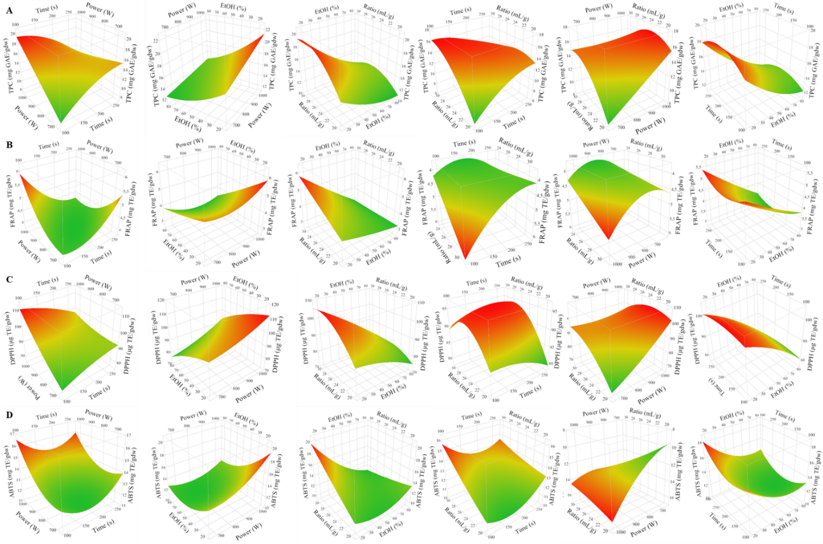
Figure S1. 3D response surfaces plots for TPC (A), FRAP (B), DPPH (C), and ABTS (D) as a function of the interaction terms (irradiation time/MW power; MW power/EtOH concentration; EtOH concentration/solvent-to-solid ratio; irradiation time/solvent-to-solid ratio; MW power/solvent-to-solid ratio; EtOH concentration/irradiation time).

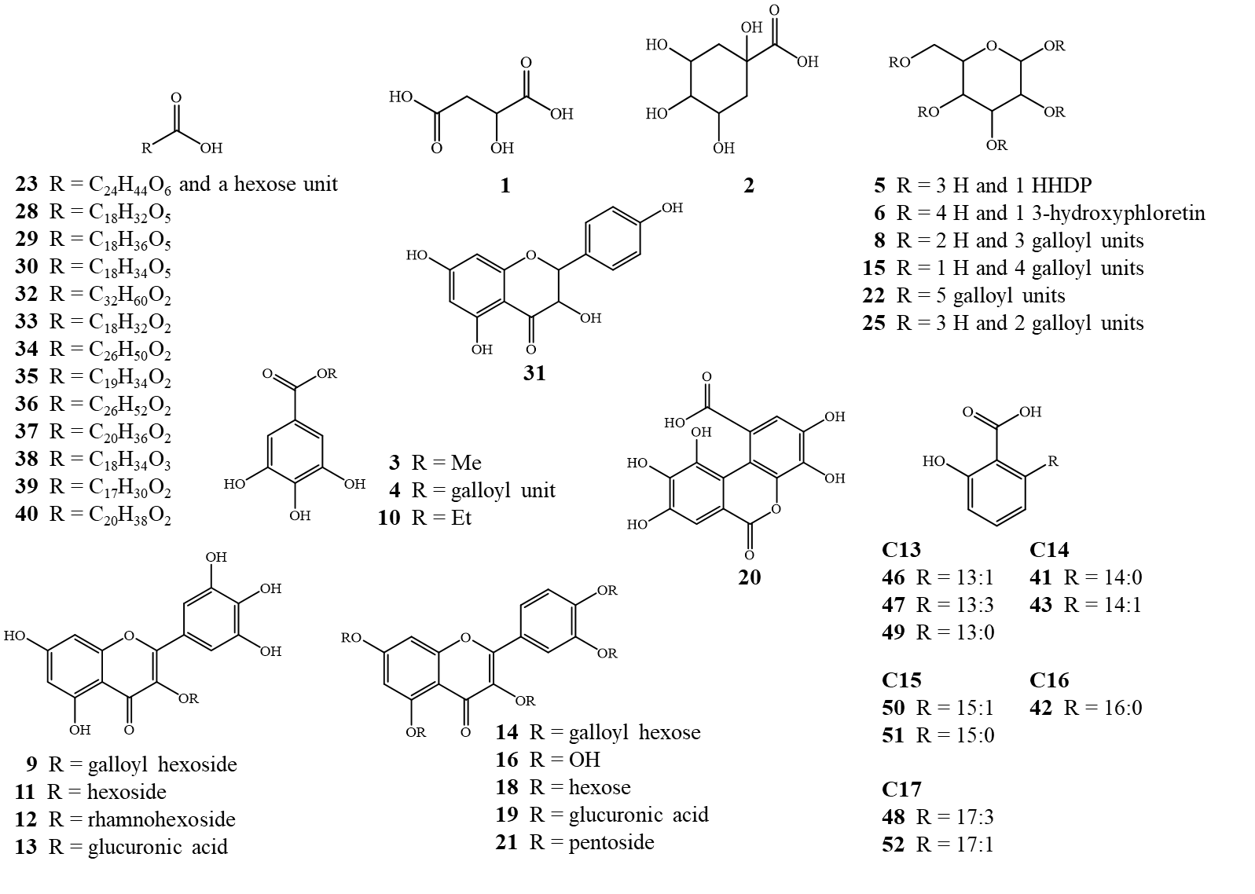
Figure S2. Chemical structures of the organic constituents tentatively identified in the optimized extract from Pistacia vera L. shells.

MS/MS key fragmentation data of the tentatively identified compounds

Gallic acid derivatives
A total of 11 gallic acid derivatives, including hydrolyzable tannins, were tentatively identified in the optimized extract from Pistacia vera shells (OPVS-E), mainly based on the characteristic product ions at m/z 169 (deprotonated gallic acid) and 125 (gallic acid − CO₂ − H), as well as due to the specific neutral losses of gallic acid, (M – H – 170) and of a galloyl moiety (M – H − 152).
Compound 3 exhibited a molecular ion [M−H]⁻ at m/z 183 and fragment ions at m/z 168 and at m/z 124, corresponding to the loss of a methyl group (M – H − CH₃) and the consecutive loss of a methyl and a carboxyl group (M – H − CH₃ −CO₂), respectively. Hence, it was tentatively identified as methyl gallate (Cardullo, Leanza, Muccilli, & Tringali, 2021).
Compounds 4 was tentatively identified as digallic acid, according to its parent ion [M−H]⁻ at m/z 321, as well as the characteristic fragment ions at m/z 169 and m/z 125 (Ersan, Ustundag, Carle, & Schweiggert, 2016). Further, compounds 5, with a [M−H]⁻ at m/z 481, was identified as hexahydroxydiphenoyl (HHDP)-hexose isomer by the presence of a fragment ion at m/z 301 (M – H − 180) derived from the dilactonisation of HHDP (Cardullo, Muccilli, Saletti, Giovando, & Tringali, 2018).
Compound 7 presented a molecular ion [M – H]⁻ at m/z 373 and the same characteristic fragmentation pattern reported by El-Sayed et al., corresponding to an acetyl-O-galloyl hexose (El-Sayed, Abbas, Refaat, El-Shafae, & Fikry, 2021; Sobeh et al., 2019).
Compounds 8, 15, and 22 exhibited their molecular ions [M − H]⁻ at m/z 635, 787, and 939, respectively. Their MS/MS spectra showed characteristic fragmentation patterns originated by the sequential losses of galloyl moieties (M – H – 170 – 152). Therefore, these compounds were tentatively identified as tri-, tetra-, and pentagalloylglucose isomers, respectively (Cardullo et al., 2021; Cardullo et al., 2018; Muccilli, Cardullo, Spatafora, Cunsolo, & Tringali, 2017).
Compound 10 was identified as ethyl gallate, according to the presence of a parent ion [M − H]⁻ at m/z 197 and of fragment ions at m/z 169 and at m/z 125, corresponding to the loss of an ethyl unit (M – H –28) and to the consecutive loss of a gallic acid moiety and of a CO₂ group (M – H –28−44), respectively (Sun, Liang, Bin, Li, & Duan, 2007).
Compound 20 showed a parent ion [M − H]⁻ at m/z 319 and was tentatively identified as luteic acid, according to a previous study (Ersan et al., 2016).
Compound 24 showed a parent ion [M – H]⁻ at m/z 347. Its fragmentation pattern resulted in product ions at m/z 267 and at m/z 169. Due to the formation of a deprotonated gallic acid in the MS/MS spectrum, it was tentatively identified as gallic acid derivative (Ersan et al., 2016).
Compound 25 showed a parent ion [M − H]⁻ at m/z 483. It was tentatively identified as digalloyl hexose by the presence of daughter ions at m/z 465 (loss of water, M – H – 18), at m/z 331 (loss of a galloyl unit, M – H – 152), at m/z 321 (loss of a hexose moiety, M – H – 162), and at m/z 313 (loss of gallic acid, M – H – 170), as well as at m/z 169 (loss of galloylglucose, M – H – 314) (Cardullo et al., 2018).

Flavonoids
A total of 14 flavonoids were tentatively identified in OPVS-E, including quercetin and myricetin derivatives. Diagnostic fragment ions at m/z 301, corresponding to the deprotonated quercetin, and at m/z 271, 255, 179 and 151, derived from the fragmentation of the quercetin aglycone, were observed in the MS/MS spectra.
Compound 6 was tentatively identified as aspalathin (3-hydroxyphloretin-O-glucoside), a flavonoid previously identified by M. Razola-Diaz et al. in tiger nut by-products (Razola-Diaz, Gomez-Caravaca, Guerra-Hernandez, Garcia-Villanova, & Verardo, 2022).
The parent ion [M − H]⁻ of compound 9 at m/z 631 was characterized by fragment ions at m/z 479, corresponding to the loss of the galloyl moiety (M – H – 152), and at m/z 317, originated from the sequential loss of both a galloyl and an hexose moiety (M – H – 152 – 162). Therefore, this compound was tentatively identified as myricetin galloyl hexoside (Ersan et al., 2016).
Compound 11 showed a signal [M−H]⁻ at m/z 479 and MS/MS fragment ions at m/z 317 and 271, corresponding to the loss of a hexose (M – H − 162) unit and to the consecutive loss of both CO and H₂O (M – H – 162 – CO – H₂O), respectively. For these reasons, this compound was tentatively identified as myricetin hexoside (Cardullo et al., 2021).
Compounds 12 and 13 were tentatively identified as myricetin rhamno-hexoside and myricetin hexuronide, respectively. The first one gave a parent ion [M – H]⁻ at m/z 625 with MS/MS fragment ions at m/z 271, 316 and 317 suggesting a derivative of the flavonol myricetin (Bystrom, Lewis, Brown, Rodriguez, & Obendorf, 2008). The second one showed its molecular ion [M − H]⁻ at m/z 493 and a peculiar fragment ion at m/z 317, indicating the loss of a uronic acid moiety (Ersan et al., 2016).
Compound 14 showed the molecular ion [M – H]⁻ at m/z 615 and, in the MS² spectrum, product ions at m/z 301, related to quercetin, m/z 463, originated from the loss of a galloyl unit, and m/z 453, indicating the loss of a glucosyl residue. Hence, compound 14 was tentatively identified as quercetin-galloyl-hexoside isomer (Ersan et al., 2016).
Compound 16, with [M−H]⁻ at m/z 303, was tentatively identified as taxifolin by the presence of diagnostic fragments at m/z 285 (loss of H₂O, M – H – 18), and 125 (M – H –178) (Lech, 2020).
Compound 17 exhibited a molecular ion [M – H]⁻ at m/z 609 and two predominant fragments at m/z 301 and 300, suggesting the presence of quercetin as aglycone. Furthermore, a product ion at m/z 463 was observed in the MS/MS spectrum (M – H – 146). due to the neutral loss of a deoxyhexose unit. Quercetin was confirmed as aglycone by its characteristic fragments (m/z 271, 255, and 179). Thus, compound 17 was tentatively identified as quercetin-O-hexosedeoxyhexoside (Fraige et al., 2018).
The MS/MS spectrum of compound 18 ([M – H]⁻ at m/z 463) suggested the presence of the quercetin aglycone and of a hexose moiety, verified by an intense peak at m/z 301 (M – H – 162) and at m/z 271 and 255. This compound was tentatively identified as quercetin hexoside, according to a previously reported study on pistachio hulls (Ersan et al., 2016). Compound 19 presented a molecular ion [M – H]⁻ at m/z 477 and a fragment ion at m/z 301, indicating the loss of a glucuronide group and the presence of the quercetin aglycone. This fragmentation pattern is coherent with quercetin monoglucuronide (Mekam, Martini, Nguefack, Tagliazucchi, & Stefani, 2019).
The molecular ion [M – H]⁻ at m/z 433 (compound 21) was tentatively identified as quercetin pentoside, due to the presence of a daughter ion at m/z 301 (M – H – 132), suggesting the loss of a pentose, and of a fragment ion at m/z 271, characteristic for 3-O-glycosyl flavonols (M – H – CH₂O) (Cardullo et al., 2021).
Compound 26 showed a parent ion at m/z 301, and a fragmentation pattern corresponding to quercetin (Cardullo et al., 2021). Compound 27 showed a molecular ion [M – H]⁻ at m/z 285, which could be assigned to kaempferol (Cardullo et al., 2021). Compound 31 showed a molecular ion [M – H]⁻ at m/z 287 and diagnostic fragments at m/z 269 (M – H – H₂O) and 251 (M – H – 2H₂O), indicating the presence of a dihydroflavonol skeleton. Therefore, it was tentatively identified as dihydrokaempferol (Assar et al., 2021).

Fatty acids and anacardic acids
Compound 23 ([M – H]⁻ at m/z 427) was tentatively identified as tentatively identified as the glycoside of 39 due to the presence, in the MS/MS spectrum, of an intense peak at m/z 265, originated by the loss of a hexose moiety (M – H – 162).
Compounds 28 – 30, 35 and 38 exhibited their molecular ions [M–H]– at m/z = 327, 331, 329, 293 and 297, respectively, and a typical daughter ion at m/z 171, originated from the loss of both a carboxyl and a hydroxyl group (–OOC(CH₂)₇CH-OH). Additionally, fragment ions deriving from a neutral loss of [M – H – 100] were observed in their MS/MS spectra, due to the fragmentation of the end-group HO-CH=CH(CH₂)₃CH₃ (Levandi, Pussa, Vaher, Toomik, & Kaljurand, 2009).
Fatty acids present a carboxylic acid moiety as polar functional group and, after collisional activation, produce a characteristic pattern of daughter ions. Notably, formation of [M – H – H₂O]– and [M – H – CO₂]– anions can typically be observed for them (Cheng & Gross, 1998). Compounds 32, 34, 36, 37, 40 and 45 showed their negative molecular ions [M – H]⁻ at m/z 475, 393, 395, 307, 309, and 289, respectively, and exhibited fragment ions corresponding to the typical losses of the carboxyl group (M – H – 44) and of a water molecule (M – H – 18) (Murphy, 2014). Additionally, their molecular masses were compared with the information retrieved from LIPID MAPS® Structure Database (LMSD), supporting their tentative identifications (Sud et al., 2007).
Compound 33 ([M – H]⁻ at m/z 279) showed a fragmentation pattern corresponding to linoleic acid. Daughter ions at m/z 261 (M – H – H₂O), and at m/z 235, due to the loss of the carboxyl group (M – H – 44) were observed in the MS/MS spectrum (Perret, Gentili, Marchese, Sergi, & Caporossi, 2004).
Compound 44 was tentatively identified as erucic acid. It exhibited a molecular ion [M – H]⁻ at m/z 337, and two product ions at m/z 293 (M – H – 18), and 319 (M – H – 44), corresponding to the loss of a water molecule and a carboxyl group, respectively (Murphy, 2014).
Ten distinct anacardic acids (41 – 43, 46 – 52) were tentatively identified in OPVS-E. These phenolic lipids differed in the alkyl chain lengths (C13, C14, C15, C16 and C17) and in the degree of unsaturation. However, indicative fragment ions originated from the cleavage of CO₂ carboxyl-functions (M – H – 44) was observed for all of them (Skrjabin, Murillo-Velasquez, Winterhalter, & Jerz, 2011). Furthermore, compound 47 exhibited a fragment ion at m/z 107, suggesting the loss of the phenol group (Ersan et al., 2016).

Other constituents
Two organic acids (compounds 1 and 2) were tentatively identified in OPVS-E thanks to the presence of diagnostic fragment ions corresponding to the loss of H₂O (M – H – 18) and CO₂ (M – H – 44).
Compound 1 exhibited a molecular ion [M – H]⁻ at m/z 133 and fragment ions at m/z 115 (M – H – 18), and 89 (M – H – 44). Hence, it was tentatively identified as malic acid (Al Kadhi, Melchini, Mithen, & Saha, 2017).
Compound 2 showed an intense molecular ion [M – H]⁻ at m/z 191, corresponding to the deprotonated quinic acid. This latest produced fragment ions at m/z 173 (M – H – 18), 147 (M – H – 44) and 111, originated from the consecutive loss of two water molecules and a carboxyl group (Mekam et al., 2019; Zhang et al., 2018).

References
Al Kadhi, O., Melchini, A., Mithen, R., & Saha, S. (2017). Development of a LC-MS/MS Method for the Simultaneous Detection of Tricarboxylic Acid Cycle Intermediates in a Range of Biological Matrices. Journal of Analytical Methods in Chemistry, 2017. https://doi.org/10.1155/2017/5391832.
Assar, D. H., Mokhbatly, A. A., Ghazy, E. W., Ragab, A. E., Abou Asa, S., Abdo, W., . . . El-Far, A. H. (2021). Ameliorative Effects of Aspergillus awamori against the Initiation of Hepatocarcinogenesis Induced by Diethylnitrosamine in a Rat Model: Regulation of Cyp19 and p53 Gene Expression. Antioxidants, 10(6). https://doi.org/10.3390/antiox10060922.
Bystrom, L. M., Lewis, B. A., Brown, D. L., Rodriguez, E., & Obendorf, R. L. (2008). Characterisation of phenolics by LC-UV/Vis, LC-MS/MS and sugars by GC in Melicoccus bijugatus Jacq. 'Montgomery' fruits. Food Chemistry, 111(4), 1017-1024. https://doi.org/10.1016/j.foodchem.2008.04.058.
Cardullo, N., Leanza, M., Muccilli, V., & Tringali, C. (2021). Valorization of Agri-Food Waste from Pistachio Hard Shells: Extraction of Polyphenols as Natural Antioxidants. Resources-Basel, 10(5). https://doi.org/10.3390/resources10050045.
Cardullo, N., Muccilli, V., Saletti, R., Giovando, S., & Tringali, C. (2018). A mass spectrometry and H-1 NMR study of hypoglycemic and antioxidant principles from a Castanea sativa tannin employed in oenology. Food Chemistry, 268, 585-593. https://doi.org/10.1016/j.foodchem.2018.06.117.
Cheng, C. F., & Gross, M. L. (1998). Fragmentation mechanisms of oxofatty acids via high-energy collisional activation. Journal of the American Society for Mass Spectrometry, 9(6), 620-627. https://doi.org/10.1016/s1044-0305(98)00023-3.
El-Sayed, M. A., Abbas, F. A., Refaat, S., El-Shafae, A. M., & Fikry, E. (2021). UPLC-ESI-MS/MS Profile of The Ethyl Acetate Fraction of Aerial Parts of Bougainvillea 'Scarlett O'Hara' Cultivated in Egypt. Egyptian Journal of Chemistry, 64(2), 793-806. https://doi.org/10.21608/ejchem.2020.45694.2933.
Ersan, S., Ustundag, O. G., Carle, R., & Schweiggert, R. M. (2016). Identification of Phenolic Compounds in Red and Green Pistachio (Pistacia vera L.) Hulls (Exo- and Mesocarp) by HPLC-DAD-ESI-(HR)-MSn. Journal of Agricultural and Food Chemistry, 64(26), 5334-5344. https://doi.org/10.1021/acs.jafc.6b01745.
Fraige, K., Dametto, A. C., Zeraik, M. L., de Freitas, L., Saraiva, A. C., Medeiros, A. I., . . . Bolzani, V. S. (2018). Dereplication by HPLC-DAD-ESI-MS/MS and Screening for Biological Activities of Byrsonima Species (Malpighiaceae). Phytochemical Analysis, 29(2), 196-204. https://doi.org/10.1002/pca.2734.
Lech, K. (2020). Universal analytical method for characterization of yellow and related natural dyes in liturgical vestments from Krakow. Journal of Cultural Heritage, 46, 108-118. https://doi.org/10.1016/j.culher.2020.04.011.
Levandi, T., Pussa, T., Vaher, M., Toomik, P., & Kaljurand, M. (2009). Oxidation products of free polyunsaturated fatty acids in wheat varieties. European Journal of Lipid Science and Technology, 111(7), 715-722. https://doi.org/10.1002/ejlt.200800286.
Mekam, P. N., Martini, S., Nguefack, J., Tagliazucchi, D., & Stefani, E. (2019). Phenolic compounds profile of water and ethanol extracts of Euphorbia hirta L. leaves showing antioxidant and antifungal properties. South African Journal of Botany, 127, 319-332. https://doi.org/10.1016/j.sajb.2019.11.001.
Muccilli, V., Cardullo, N., Spatafora, C., Cunsolo, V., & Tringali, C. (2017). alpha-Glucosidase inhibition and antioxidant activity of an oenological commercial tannin. Extraction, fractionation and analysis by HPLC/ESI-MS/MS and H-1 NMR. Food Chemistry, 215, 50-60. https://doi.org/10.1016/j.foodchem.2016.07.136.
Murphy, R. C. (2014). Fatty Acids. In R. C. Murphy (Ed.), Tandem Mass Spectrometry of Lipids (pp. 1-38): Robert C Murphy https://doi.org/10.1039/9781782626350-00001.
Perret, D., Gentili, A., Marchese, S., Sergi, M., & Caporossi, L. (2004). Determination of free fatty acids in chocolate by liquid chromatography with tandem mass spectrometry. Rapid Communications in Mass Spectrometry, 18(17), 1989-1994. https://doi.org/10.1002/rcm.1582.
Razola-Diaz, M. D., Gomez-Caravaca, A. M., Guerra-Hernandez, E. J., Garcia-Villanova, B., & Verardo, V. (2022). New Advances in the Phenolic Composition of Tiger Nut (Cyperus esculentus L.) by-Products. Foods, 11(3). https://doi.org/10.3390/foods11030343.
Skrjabin, I., Murillo-Velasquez, J. A., Winterhalter, P., & Jerz, G. (2011). Anacardic acid profiling in food plants by direct coupling of preparative high-speed countercurrent chromatography and electrospray/APCI mass-spectrometry (prepHSCCC-ESI/APCI-MS/MS). Abstracts of Papers of the American Chemical Society, 242.
Sobeh, M., Rezq, S., Sabry, O. M., Abdelfattah, M. A. O., El Raey, M. A., El-Kashak, W. A., . . . Wink, M. (2019). Albizia anthelmintica: HPLC-MS/MS profiling and in vivo anti-inflammatory, pain killing and antipyretic activities of its leaf extract. Biomedicine & Pharmacotherapy, 115. https://doi.org/10.1016/j.biopha.2019.108882.
Sud, M., Fahy, E., Cotter, D., Brown, A., Dennis, E. A., Glass, C. K., . . . Subramaniam, S. (2007). LMSD: LIPID MAPS structure database. Nucleic Acids Research, 35, D527-D532. https://doi.org/10.1093/nar/gkl838.
Sun, J. Q., Liang, F., Bin, Y., Li, P., & Duan, C. Q. (2007). Screening non-colored phenolics in red wines using liquid chromatography/ultraviolet and mass spectrometry/mass spectrometry libraries. Molecules, 12(3), 679-693. https://doi.org/10.3390/12030679.
von Reuss, S. H., Bose, N., Srinivasan, J., Yim, J. J., Judkins, J. C., Sternberg, P. W., & Schroeder, F. C. (2012). Comparative Metabolomics Reveals Biogenesis of Ascarosides, a Modular Library of Small-Molecule Signals in C. elegans. Journal of the American Chemical Society, 134(3), 1817-1824. https://doi.org/10.1021/ja210202y.
Zhang, Y., Xiong, H., Xu, X. F., Xue, X., Liu, M. N., Xu, S. Y., . . . Li, X. R. (2018). Compounds Identification in Semen Cuscutae by Ultra-High-Performance Liquid Chromatography (UPLCs) Coupled to Electrospray Ionization Mass Spectrometry. Molecules, 23(5). https://doi.org/10.3390/molecules23051199.

