ELECTRONIC SUPPORTING INFORMATION
A Supramolecular Assembly Made with Sulfobutylether-β-cyclodextrin and Magnetic Fe₃O₄ Showing Water Remediation Properties
Nina Burduja ^{a, b, †}, Giuseppe Nocito ^{a, †, *}, Mariachiara Trapani ª, Alberto Riminucci ^{c}, Riccardo Di Corato ^{d, e}, Angelo Nicosia ^{f, g}, Antonino Gulino ^{f, g}, Placido Giuseppe Mineo ^{f, g} and Antonino Mazzaglia ^{a, *}
ª National Research Council, Institute for the Study of Nanostructured Materials (CNR-ISMN) URT of Messina at the Department of Chemical, Biological, Pharmaceutical and Environmental Sciences (ChiBioFarAm), University of Messina – Viale Ferdinando Stagno d’Alcontres, 31 98166 Messina, Italy.
^{b} Department of Chemical, Biological, Pharmaceutical and Environmental Sciences (ChiBioFarAm), University of Messina – Viale Ferdinando Stagno d’Alcontres, 31 98166 Messina, Italy.
^{c} National Research Council, Institute for the Study of Nanostructured Materials (CNR-ISMN) Bologna – Via Piero Gobetti, 101 40129 Bologna, Italy
^{d} National Research Council, Institute for Microelectronics and Microsystems (CNR-IMM) Lecce – SP Lecce-Monteroni Km 1,200 73100 Lecce, Italy
^{e} Center for Biomolecular Nanotechnologies, Istituto Italiano di Tecnologia, Arnesano 73010, Italy
^{f} Department of Chemical Sciences, University of Catania – Viale Andrea Doria, 6 95125 Catania, Italy
^{g} I.N.S.T.M. UdR of Catania, Viale Andrea Doria, 6 95125 Catania, Italy
* Corresponding authors: Dr. Giuseppe Nocito (giuseppe.nocito@cnr.it), Dr. Antonino Mazzaglia (antonino.mazzaglia@cnr.it)
† These authors contributed equally

Figure S1. Thermogravimetric traces (air atmosphere) of MNPs (black line), MNPs@Captisol 1:1 w/w (red line), MNPs@Captisol 1:2 w/w (green line), and MNPs@Captisol 1:4 w/w (blue line).
Figure S2 Mass magnetization hysteresis loops of pristine MNPs (black line), MNPs@Captisol 1:1 (red line), MNPs@Captisol 1:2 (green line) and MNPs@Captisol 1:4 (blue line)
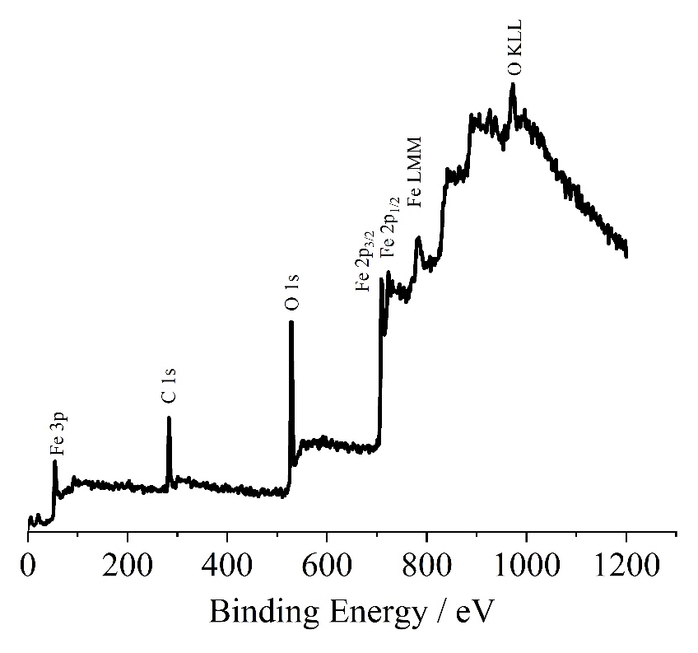
Figure S3. Al-Kα excited XPS survey spectrum of MNPs@Captisol.

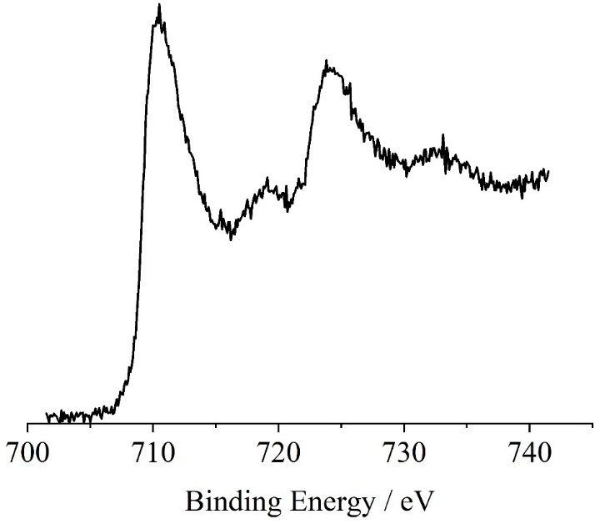
Figure S4. Al-Kα excited XPS of the pristine MNPs in the Fe 2p binding energy region.

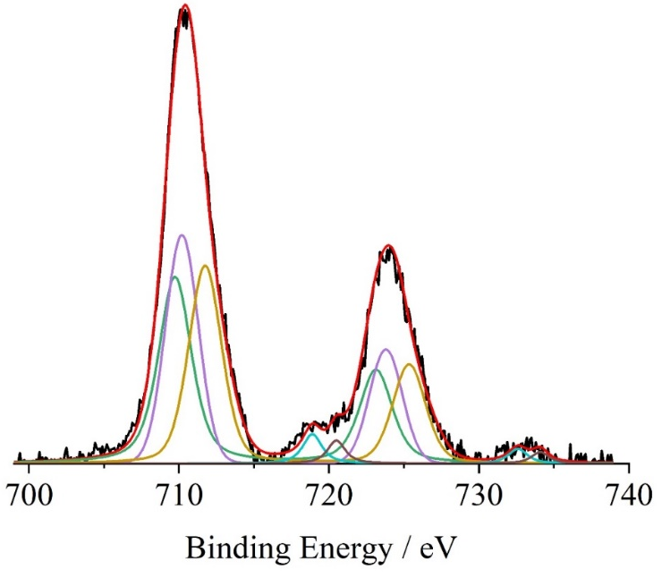
Figure S5. Al-Kα excited XPS of the MNPs@Captisol in the Fe 2p binding energy region, after subtraction of the background. The green, violet, yellow, light blue and brown lines refer to the 709.6, 710.5, 712.4, 718.9 and 720.5 eV components, respectively. The blue line refers to the background and the red line superimposed to the black experimental profile refers to the sum of all the Gaussian components.
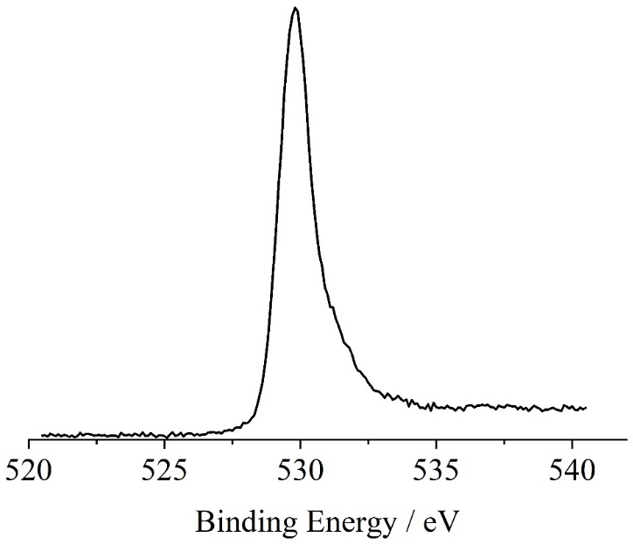
Figure S6. Al-Kα excited XPS of the pristine MNPs in the O 1s core level binding energy region.

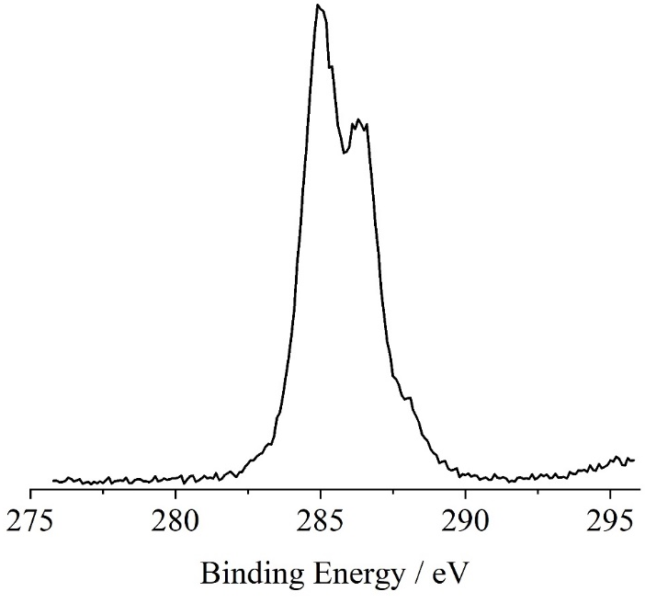
Figure S7. Al-Kα excited XPS of the of the pristine Captisol in the C 1s binding energy region.

Figure S8. Evaluation of the colloidal stability at 25 °C of 82 μg/mL MNPs and MNPs@Captisol in ultrapure water using adapted turbidimetric method. The extinction values at 790 nm are plotted vs time and fitted with a first-order exponential decay equation. Samples are compared for the half-life (t _{½}) values.

Figure S9. Graphical representation of the mean hydrodynamic diameter (D_{H}) as intensity percentage from DLS stability analysis of 82 μg/mL aqueous colloidal dispersion of MNPs.
Figure S10. Graphical representation of the mean hydrodynamic diameter (D_{H}) as intensity percentage from DLS stability analysis of 82 μg/mL aqueous colloidal dispersion of MNPs@Captisol.

Table S1. Colloidal properties from DLS analysis in ultrapure water: average hydrodynamic diameter (D_{H}), percentage of intensity distribution (%), Polydispersity Index (PDI), ζ-potential (ζ), standard deviation (SD). Data were acquired at 25 °C on freshly prepared samples.
Sample | Time (min) | D_{H} (nm ± SD) (%) | PDI | ζ (mV ± SD)
MNPs@Captisol | 0 | 1152 ± 310 (89) | 0.07 | -1.5 ± 5
MNPs@Captisol | 30 | 1262 ± 295 (98) | 0.05 | -
MNPs@Captisol | 120 | 1137 ± 247 | 0.05 | -
MNPs | 0 | 512 ± 100 (87)  112 ± 16 (12) | 0.04  0.02 | +30 ± 6
MNPs | 30 | 709 ± 250 (73)  151 ± 37 (22) | 0.12  0.06  0.01 | -
MNPs | 60 | 533 ± 361 (90) | N.D. | -
MNPs | 90 | 518 ± 225 (66)  152 ± 42 (29) | 0.19  0.07 | -
MNPs | 120 | 347 ± 233 (94) | N.D. | -
[MNPs@Captisol] = [MNPs] = 82 μg/mL
PDI values are calculated from the single peak using the following equation $PDI={{SD}^{2}}/{{D_{H}}^{2}}$
Large aggregate fraction (D_{H} ⁓ 4-5 μm) was found but not included which abundance was ≤ 5 %.

Figure S11. Evaluation of the colloidal stability at 25 °C of 62.5 μg/mL MNPs and MNPs@Captisol in ultrapure water using adapted turbidimetric method. The extinction values at 790 nm are plotted vs time and fitted with a first-order exponential decay equation. Samples are compared for the half-life (t _{½}) values.

Figure S12. Graphical representation of the mean hydrodynamic diameter (D_{H}) as intensity percentage from DLS stability analysis of 62.5 μg/mL aqueous colloidal dispersion of MNPs.
Figure S13. Graphical representation of the mean hydrodynamic diameter (D_{H}) as intensity percentage from DLS stability analysis of 62.5 μg/mL aqueous colloidal dispersion of MNPs@Captisol.
Table S2. Colloidal properties from DLS analysis in ultrapure water: average hydrodynamic diameter (D_{H}), percentage of intensity distribution (%), Polydispersity Index (PDI), ζ-potential (ζ), standard deviation (SD). Data were acquired at 25 °C on freshly prepared samples.
Sample | Time (min) | D_{H} (nm ± SD) | PDI | ζ (mV ± SD)
MNPs@Captisol | 0 | 829 ± 129 | 0.03 | -9 ± 5
MNPs@Captisol | 30 | 761 ± 105 | 0.02 | -
MNPs@Captisol | 60 | 709 ± 158 | 0.05 | -
MNPs@Captisol | 90 | 627 ± 139 | 0.05 | -
MNPs@Captisol | 120 | 546 ± 88 | 0.03 | -
MNPs | 0 | 562 ± 214 (81)  125 ± 30 (13) | 0.14  0.05 | +28 ± 6
MNPs | 30 | 960 ± 316 (69)  178 ± 46 (27) | 0.1  0.07 | -
MNPs | 60 | 1011 ± 306 (60)  190 ± 51 (30) | 0.09  0.07 | -
MNPs | 90 | 926 ± 296 (61)  178 ± 50 (31) | 0.1  0.08 | -
MNPs | 120 | 773 ± 326 (55)  200 ± 76 (39) | 0.18  0.14 | -
[MNPs@Captisol] = [MNPs] = 62.5 μg/mL
PDI values are calculated from the single peak using the following equation $PDI={{SD}^{2}}/{{D_{H}}^{2}}$
Large aggregate fraction (D_{H} ⁓ 4-5 μm) was found but not included which abundance was ≤ 5 %.

Figure S14. Evaluation of the colloidal stability at 25 °C of 41.67 μg/mL MNPs and MNPs@Captisol in ultrapure water using adapted turbidimetric method. The extinction values at 790 nm are plotted vs time and fitted with a first-order exponential decay equation. Samples are compared for the half-life (t _{½}) values.

Figure S15. Graphical representation of the mean hydrodynamic diameter (D_{H}) as intensity percentage from DLS stability analysis of 41.67 μg/mL aqueous colloidal dispersion of MNPs.
Figure S16. Graphical representation of the mean hydrodynamic diameter (D_{H}) as intensity percentage from DLS stability analysis of 41.67 μg/mL aqueous colloidal dispersion of MNPs@Captisol.

Table S3. Colloidal properties from DLS analysis in ultrapure water: average hydrodynamic diameter (D_{H}), percentage of intensity distribution (%), Polydispersity Index (PDI), ζ-potential (ζ), standard deviation (SD). Data were acquired at 25 °C on freshly prepared samples.
Sample | Time (min) | D_{H} (nm ± SD) (%) | PDI | ζ (mV ± SD)
MNPs@Captisol | 0 | 753 ± 179 | 0.06 | -4 ± 5
MNPs@Captisol | 30 | 1048 ± 291 (95) | 0.08 | -
MNPs@Captisol | 60 | 1002 ± 208 | 0.04 | -
MNPs@Captisol | 90 | 1251 ± 270 (99) | 0.04 | -
MNPs@Captisol | 120 | 1084 ± 274 | 0.06 | -
MNPs | 0 | 350 ± 86 (85)  90 ± 16 (15) | 0.06  0.03 | +30 ± 5
MNPs | 30 | 382 ± 304 (92) | N.D. | -
MNPs | 60 | 212 ± 97 (58)  985 ± 393 (34) | 0.20  0.16 | -
MNPs | 90 | 450 ± 202 (55)  146 ± 45 (41) | N.D. | -
MNPs | 120 | 292 ± 188 (91) | N.D. | -
[MNPs@Captisol] = [MNPs] = 41.67 μg/mL
PDI values are calculated from the single peak using the following equation $PDI={{SD}^{2}}/{{D_{H}}^{2}}$
Large aggregate fraction (D_{H} ⁓ 4-5 μm) was found but not included which abundance was ≤ 5 %.

Figure S17. Water remediation experiments on 62.5 μg/mL water dispersions of MNPs@Captisol and MNPs performed until 40 min with 10 μM solution of methylorange.

Figure S18. Complexation experiments of Captisol and paraquat in different molar ratios.

